**SHIP CLASSIFICATION USING IBM WATSON**

A Mini Project Report Submitted to

**JAWAHARLAL NEHRU TECHNOLOGICAL UNIVERSITY,**

**HYDERABAD**

In partial fulfillment of the requirements for the award of the degree of

**BACHELOR OF TECHNOLOGY**

**IN**

**COMPUTER SCIENCE AND ENGINEERING**

Submitted by

**G. AKHILA 19UK1A05N2**

**A. MOUNIKA 20UK5A0502**

**G. PAVAN KUMAR 19UK1A05M8**

**M. DILIP 18UK1A0536**

**P.SAI KIRAN 18UK1A05G5**

Under the esteemed guidance of

**Dr.P. MAHIPAL REDDY**

(Assistant Professor)



**DEPARTMENT OF COMPUTER SCIENCE AND ENGINEERING VAAGDEVI ENGINEERING COLLEGE**

(Affiliated to JNTUH, Hyderabad)

Bollikunta, Warangal – 506005

**2019– 2023**

## **DEPARTMENT OF COMPUTER SCIENCE AND ENGINEERING**

**VAAGDEVI ENGINEERING COLLEGE**

**BOLLIKUNTA, WARANGAL – 506005**

**2019 – 2023**



**CERTIFICATE**

This is to certify that the Industry Oriented Mini Project entitled **“SHIP CLASSIFICATION USING IBM WATSON”** is being submitted by GAJJALA AKHILA (19UK1A05N2), NAMSANI SUSHMA (19UK1A05L6), GANGIDI RAJU (19UK1A05K7), ANNAVAJJALA SHARVANI (19UK1A05L3), in partial fulfillment of the requirements for the award of the degree of **Bachelor of Technology** in **Computer Science and Engineering** to **Jawaharlal Nehru Technological University Hyderabad** during the academic year **2022-23**, is a record of work carried out by them under the guidance and supervision.

**Project Guide**  **Head Of the Department**

**Dr.P. MAHIPAL REDDY** **DR.R. NAVEEN KUMAR**

## **ACKNOWLEDGEMENT**

We wish to take this opportunity to express our sincere gratitude and deep sense of respect to our beloved **Dr.P.PRASAD RAO,** Principal, Vaagdevi Engineering College for making us available all the required assistance and for his support and inspiration to carry out this Industry Oriented Mini Project in the institute.

We extend our heartfelt thanks to **Dr.R.NAVEEN KUMAR**, Head of the Department of CSE, Vaagdevi Engineering College for providing us necessary infrastructure and thereby giving us freedom to carry out the Industry Oriented Mini Project.

We express heartfelt thanks to Smart Bridge Educational Services Private Limited, for their constant supervision as well as for providing necessary information regarding the Industry Oriented Mini Project and for their support in completing the Industry Oriented Mini Project.

We express heartfelt thanks to the guide, **Dr.P.MAHIPAL REDDY** Assistant professor, Department of CSE for her constant support and giving necessary guidance for completion of this Industry Oriented Mini Project.

Finally, we express our sincere thanks and gratitude to my family members, friends for their encouragement and outpouring their knowledge and experience throughout the thesis.

**G. AKHILA 19UK1A05N2**

**A. MOUNIKA 20UK5A0502**

**G. PAVAN KUMAR 19UK1A05M8**

**M. DILIP 18UK1A0536**

**P.SAI KIRAN 18UK1A05G5**

### ABSTRACT

With the rapid development of target tracking technology, how to efficiently take advantage of useful information from optical images for ship classification becomes a challenging problem. In this paper, a novel deep learning framework fused with low-level features is proposed. Deep convolutional neural network (CNN) has been popularly used to capture structural information and semantic context because of the ability of learning high-level features; however, lacking of capability to deal with global rotation in large-scale image and losing some important information in bottom layers of the CNN limit its performance in extracting multi-scales rotation invariance features. Comparatively, some classic algorithms, such as Gabor filter or multiple scales completed local binary patterns, can effectively capture low-level texture information. In the proposed framework, low-level features are combined with high-level features obtained by deep CNN. The fused features are further fed into a typical support vector machine classifier. The proposed strategy achieves average accuracy of 98.33% on the BCCT200-RESIZE data and 88.00% on the challenging VAIS data, which demonstrates its superior classification performance when compared with some state-of-the-art methods.

### TABLE OF CONTENTS

**1. INTRODUCTION………………………………………………………………….….1**

**2. LITERATURESURVEY………………………………………………………..... ….2**

**3. THEORITICALANALYSIS……………………………………………….….……3-6**

**4. EXPERIMENTAL INVESTIGATIONS……………………………….………...…7**

**5 .FLOW CHART…………………………………………………………………….…8**

**6. RESULT………………………………………………………………………...…9-10**

**7. ADVANTAGES &DISADVANTAGES…………………………………………11-12**

**8. APPLICATIONS…………………………………………………………….……….13**

**9. CONCLUSION……………………………………………………………………….14**

**10. FUTURE SCOPE…………………………………………………………………...15**

**11. BIBLOGRAPHY……………………………………………………………………16**

# 1. INTRODUCTION

#### 1. Overview

In this project, we introduce a new convolutional neural network classification algorithm capable of classifying five classes of ships, including cargo, military, carrier, cruise and tanker ships, in inland waterways. All the images are present in a single folder so we will first be dividing them into categories with the help of a train.csv file that contains all the filenames of the training images. The model used to train the model is VGG16, a computer vision model which is based on Convolutional Neural Networks (CNN). We will be using the pre-trained weights of the model and modify the top layer for performing our custom classification. The model is deployed using the Flask framework The purpose of ship classification is to identify different categories of ship images with as accurately as possible. Recent years, lots of researchers have made great efforts for this purpose . The visual sensor is usually significantly affected by the natural factors, such as weather and lighting conditions and so on, which makes it difficult to recognize the ship types. What’s more, wide within-class variation in some types of vessels also makes ship classification more complicated and challenging . Up to now, numerous feature extraction algorithms have been proposed for scene classification, including entropy-based hierarchical discriminant regression, completed local binary patterns (CLBP), multi-linears principal component analysis , hierarchical multi-scales local binary pattern (HMLBP) , histogram of oriented gradients, and multiple feature learning . CLBP is a local texture feature descriptor which captures structure information and extracts local features, e.g., edge feature. Compared with typical LBP, relationship between center point and adjacent points is better described, while the robustness of illumination changes and noise is enhanced. MFL is operated to obtain comprehensive representation of features via fusing the local features and global features. Based on previous work , Rainey and Stastny developed several effective recognition algorithms to separate different ship categories.

#### 2. Purpose

The purpose of ship classification is to identify various types of ships as accurately as possible, which is of great significance for monitoring the rights and interests of maritime traffic and improving coastal defense early warnings.

### 2. LITERATURE SURVEY

#### 2.1 Existing Problem

In recent years, deep learning has been used in various applications including the classification of ship targets in inland waterways for enhancing intelligent transport systems. Various researchers introduced different classification algorithms, but they still face the problems of low accuracy and misclassification of other target objects. Hence, there is still a need to do more research on solving the above problems to prevent collisions in inland waterways.

#### 2.2 Proposed Solution

In order to solve the problems for the accuracy of the classification system, we proposed a new classification model. First, based on the pretrained models, the models were fine-tuned with the public dataset we used. Based on their performance, the best model was selected in order to further adjust the performance for high accuracy in classifying ships in inland river waterways. After selecting the best model, the model was adjusted, and classification was conducted based on the modification of the network.

**3. THEORETICAL ANALYSIS**

**3.1 Block Diagram**

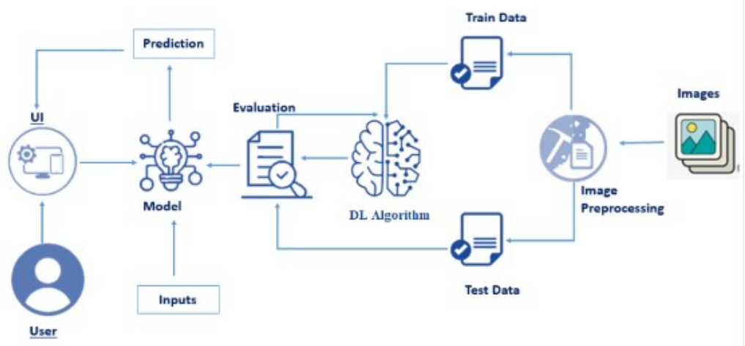

#### 3.2 Hardware / Software Designing

* Anaconda Navigator: Anaconda Navigator is a free and opensource distribution of the Python and R programming languages for data science and machine learning-related applications. It can be installed on Windows, Linux, and macOS.Conda is an opensource, cross-platform, package management system. Anaconda comes with so very nice tools like JupyterLab, Jupyter Notebook, QtConsole, Spyder, Glueviz, Orange, Rstudio, Visual Studio Code. For this project, we will be using a Jupyter notebook and Spyder.
* Python packages:
* NumPy: NumPy is a Python package that stands for 'Numerical Python. It is the core library for scientific computing, which contains a powerful n-dimensional array of objects. 4
* Pandas: pandas is a fast, powerful, flexible, and easy-to-use opensource data analysis and manipulation tool, built on top of the Python programming language.
* Matplotlib: It provides an object-oriented API for embedding plots into applications using general-purpose GUI toolkits
* Keras: Keras is an open-source library that provides a Python interface for artificial neural networks. Keras acts as an interface for the TensorFlow library. Up until version 2.3, Keras supported multiple backends, including TensorFlow, Microsoft Cognitive Toolkit, R, Theano, and PlaidML. Designed to enable fast experimentation with deep neural networks, it focuses on being user-friendly, modular, and extensible.
* TensorFlow: TensorFlow is just one part of a much bigger, and growing ecosystem of libraries and extensions that help you accomplish your machine learning goals. It is a free and opensource software library for data flow and differentiable programming across a range of tasks. It is a symbolic math library and is also used for machine learning applications such as neural networks.
* Flask: Web framework used for building Web applications
* Hardware
* Device name: DESKTOP-J5SC39S
* Processor: Intel(R) Pentium(R) Gold G5420 CPU @ 3.80GHz 3.79 GHz
* System type: 64-bit operating system, x64-based processor

# 4. EXPERIMENTAL INVESTIGATIONS

The images need to be organized before proceeding with the project. The original dataset has a single folder known as images. We will be using the train.csv file to fetch the image ID’s of training images. Then we are creating subdirectories with in train folder and move images to them. The dataset images are to be pre-processed before giving to the model. We will create a function that uses the pretrained VGG16 model for predicting custom classes. Then we have to test and train the model. After the model is build, we will be integrating it to a web application.

**5. FLOWCHARTS**

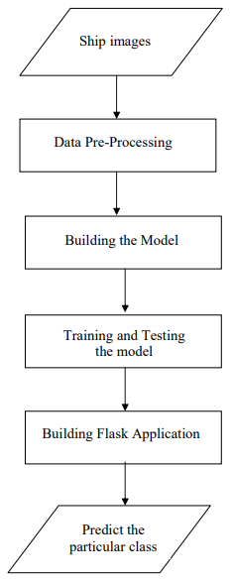

**6. RESULT**

**INPUT**

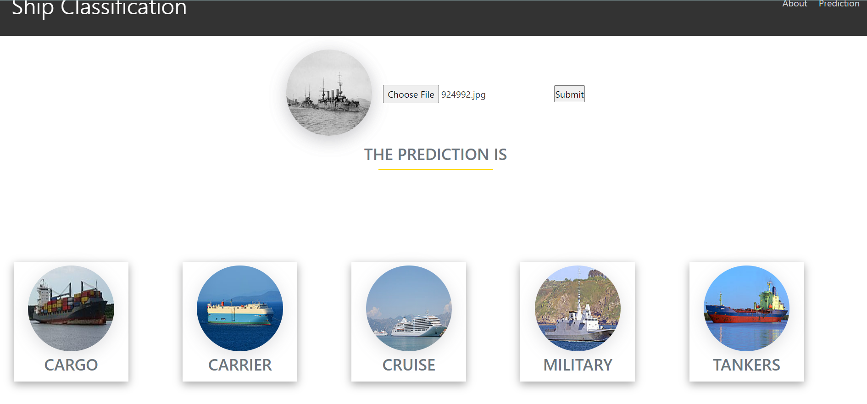

**OUTPUT**

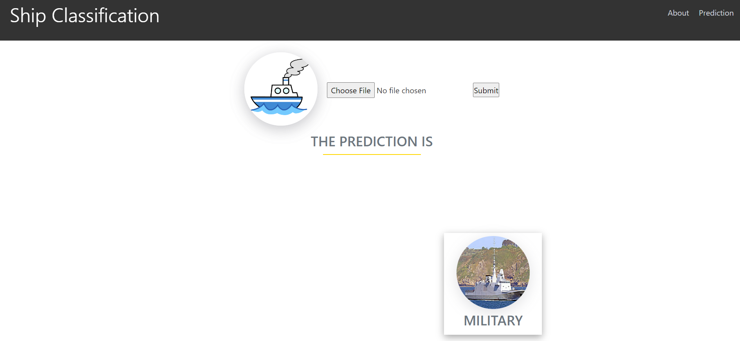

**7. ADVANTAGES AND DISADVANTAGES**

**ADVANTAGES:**

* Easy to use
* Time efficient
* Cost efficient

**DISADVANTAGES:**

* Time consuming
* Not so accurate results for small ships

**8. APPLICATIONS**

A **ship classification society** or **ship classification organisation** is a [non-governmental organization](https://en.wikipedia.org/wiki/Non-governmental_organization) that establishes and maintains technical standards for the construction and operation of [ships](https://en.wikipedia.org/wiki/Shipping) and [offshore structures](https://en.wikipedia.org/wiki/Offshore_platform). Classification societies certify that the construction of a vessel comply with relevant standards and carry out regular surveys in service to ensure continuing compliance with the standards. Currently, more than 50 organizations describe their activities as including marine classification, twelve of which are members of the [International Association of Classification Societies](https://en.wikipedia.org/wiki/International_Association_of_Classification_Societies).

A **classification certificate** issued by a classification society recognised by the proposed [ship register](https://en.wikipedia.org/wiki/Ship_registration) is required for a ship's owner to be able to register the ship and to obtain [marine insurance](https://en.wikipedia.org/wiki/Marine_insurance) on the ship, and may be required to be produced before a ship's entry into some ports or waterways, and may be of interest to charterers and potential buyers. To avoid liability, classification societies explicitly [disclaim](https://en.wikipedia.org/wiki/Disclaimer) responsibility for the safety, fitness for purpose, or [seaworthiness](https://en.wikipedia.org/wiki/Seaworthiness) of the ship, but is a verification only that the vessel is in compliance with the classification standards of the society issuing the classification certificate.

**9. CONCLUSION**

This project was about classifying the ship. This project improved the performance of the classification model for classifying ships in inland waterways. The new proposed method achieved high accuracy compared with the other existing algorithms. It was compared with other existing algorithms in classifying different classes of ships in inland waterways, and our proposed method achieved better results compared with the others. This improved the performance of the classification model for classifying ships. Initially, the pretrained models used were AlexNet, VGG16, ResNet, Inception V3 and GoogleNet for the game of deep learning sea ship public dataset, which consisted of five classes: cargo, military, carrier, cruise and tanker ships. Based on their performance, the best model was selected for further improvement. Additionally, for proper image pre-processing, a comparison of accuracy for noisy and low-contrast images will be used along with the addition of the Jaccard index to compare the accuracy of the classification.

**10. FUTURE SCOPE**

In future works, the proposed method will be improved in order to classify the ships in different weather conditions using more advanced technology.

**11. BIBLIOGRAPHY**

• <https://www.mdpi.com/2078-2489/12/8/302/htm>

• <http://cs229.stanford.edu/proj2017/final-reports/5244159.pdf>

• <https://www.kaggle.com/code/teeyee314/classification-of-ship-images/log>

**APPENDIX**

**App.py**

import re

import numpy as np

import os

from flask import Flask, app,request,render_template

from tensorflow.keras import models

from tensorflow.keras.models import load_model

from tensorflow.keras.preprocessing import image

from tensorflow.python.ops.gen_array_ops import concat

from keras.applications.vgg16 import preprocess_input

#Loading the model

model=load_model(r"vgg16-ship-classification.h5")

app=Flask(__name__)

#default home page or route

@app.route('/')

def index():

return render_template('index.html')

@app.route('/prediction.html')

def prediction():

return render_template('prediction.html')

@app.route('/index.html')

def home():

return render_template("index.html")

@app.route('/result',methods=["GET","POST"])

def res():

if request.method=="POST":

f=request.files['image']

basepath=os.path.dirname(__file__) #getting the current path i.e where app.py is present

#print("current path",basepath)

filepath=os.path.join(basepath,'uploads',f.filename) #from anywhere in the system we can give image but we want that image later to process so we are saving it to uploads folder for reusing

#print("upload folder is",filepath)

f.save(filepath)

img=image.load_img(filepath,target_size=(224,224))

img = image.img_to_array(img)

img = img.reshape((1, img.shape[0], img.shape[1], img.shape[2]))

img = preprocess_input(img)

# reshape data for the model

pred = model.predict(img)

#print(pred)

pred=pred.flatten()

pred = list(pred)

m = max(pred)

#print(pred)

#print(pred.index(m))

val_dict = {0:'Cargo', 1:'Carrier', 2:'Cruise', 3:'Military', 4:'Tankers'}

#print(val_dict[pred.index(m)])

result=val_dict[pred.index(m)]

print(result)

return render_template('prediction.html',prediction=result)

""" Running our application """

if __name__ == "__main__":

app.run()

**prediction.html**

<!DOCTYPE html>

<html lang="en">

<head>

<meta charset="UTF-8">

<meta http-equiv="X-UA-Compatible" content="IE=edge">

<meta name="viewport" content="width=device-width, initial-scale=1.0">

<!--Bootstrap -->

<link rel="stylesheet" href="https://maxcdn.bootstrapcdn.com/bootstrap/4.0.0/css/bootstrap.min.css" integrity="sha384-Gn5384xqQ1aoWXA+058RXPxPg6fy4IWvTNh0E263XmFcJlSAwiGgFAW/dAiS6JXm" crossorigin="anonymous">

<script src="https://code.jquery.com/jquery-3.2.1.slim.min.js" integrity="sha384-KJ3o2DKtIkvYIK3UENzmM7KCkRr/rE9/Qpg6aAZGJwFDMVNA/GpGFF93hXpG5KkN" crossorigin="anonymous"></script>

<script src="https://cdnjs.cloudflare.com/ajax/libs/popper.js/1.12.9/umd/popper.min.js" integrity="sha384-ApNbgh9B+Y1QKtv3Rn7W3mgPxhU9K/ScQsAP7hUibX39j7fakFPskvXusvfa0b4Q" crossorigin="anonymous"></script>

<script src="https://maxcdn.bootstrapcdn.com/bootstrap/4.0.0/js/bootstrap.min.js" integrity="sha384-JZR6Spejh4U02d8jOt6vLEHfe/JQGiRRSQQxSfFWpi1MquVdAyjUar5+76PVCmYl" crossorigin="anonymous"></script>

<script src="https://kit.fontawesome.com/8b9cdc2059.js" crossorigin="anonymous"></script>

<link href="https://fonts.googleapis.com/css2?family=Akronim&family=Roboto&display=swap" rel="stylesheet">

<link rel="stylesheet" href="../static/style.css">

<script defer src="../static/js/JScript.js"></script>

<title>Prediction</title>

</head>

<body>

<header id="head" class="header">

<section id="navbar">

<h1 class="nav-heading"><i class="fas fa-recycle m2"></i>Ship Classification</h1>

<div class="nav--items">

<ul>

<li><a href="index.html#about">About</a></li>

<li><a href="prediction.html">Prediction</a></li>

</ul>

</div>

</section>

</header>

<!-- dataset/Training/metal/metal326.jpg -->

<section id="prediction">

<div class="prediction-input">

<div class="circle">

<img src="../static/img/dummy/ship.png" alt="Demo" id="demo" class="circle">

</div>

<form id="form" action="/result" method="post" enctype="multipart/form-data">

<input type="file" id="imageupload" name="image" accept="image/*" class="input-image">

<input type="submit" class="submitbtn">

</form>

</div>

<h3 class="title text-muted">

THE PREDICTION IS

</h3>

<div class="line"></div>

<div class="output-container">

<div data-type="Cargo" class="output img1">

<img src="../static/img/testimonials/cargo.jpg" alt="" class="circle">

<h3 class="text-muted">CARGO</h3>

</div>

<div data-type="Carrier" class="output img2">

<img src="../static/img/testimonials/carrier.jpg" alt="" class="circle">

<h3 class="text-muted">CARRIER</h3>

</div>

<div data-type="Cruise" class="output img3">

<img src="../static/img/testimonials/cruise.jpg" alt="" class="circle">

<h3 class="text-muted">CRUISE</h3>

</div>

<div data-type="Military" class="output img4">

<img src="../static/img/testimonials/military.jpg" alt="" class="circle">

<h3 class="text-muted">MILITARY</h3>

</div>

<div data-type="Tankers" class="output img5">

<img src="../static/img/testimonials/tankers.jpg" alt="" class="circle">

<h3 class="text-muted">TANKERS</h3>

</div>

</div>

<div class="hide" id="result">

{{prediction}}

</div>

</section>

<section id="footer">

<p>Copyright © 2021. All Rights Reserved</p>

<div class="social">

<a href="#"_blank"><i class="fab fa-2x fa-twitter-square"></i></a>

<a href="#" target="_blank">

<i class="fab fa-2x fa-linkedin"></i></a>

<a href="#">

<i class="fab fa-instagram-square fa-2x "></i>

</a>

</div>

</section>

</body>

</html>

**Index.html**

<!DOCTYPE html>

<html lang="en">

<head>

<meta charset="UTF-8">

<meta http-equiv="X-UA-Compatible" content="IE=edge">

<meta name="viewport" content="width=device-width, initial-scale=1.0">

<!--Bootstrap -->

<link rel="stylesheet" href="https://maxcdn.bootstrapcdn.com/bootstrap/4.0.0/css/bootstrap.min.css" integrity="sha384-Gn5384xqQ1aoWXA+058RXPxPg6fy4IWvTNh0E263XmFcJlSAwiGgFAW/dAiS6JXm" crossorigin="anonymous">

<script src="https://code.jquery.com/jquery-3.2.1.slim.min.js" integrity="sha384-KJ3o2DKtIkvYIK3UENzmM7KCkRr/rE9/Qpg6aAZGJwFDMVNA/GpGFF93hXpG5KkN" crossorigin="anonymous"></script>

<script src="https://cdnjs.cloudflare.com/ajax/libs/popper.js/1.12.9/umd/popper.min.js" integrity="sha384-ApNbgh9B+Y1QKtv3Rn7W3mgPxhU9K/ScQsAP7hUibX39j7fakFPskvXusvfa0b4Q" crossorigin="anonymous"></script>

<script src="https://maxcdn.bootstrapcdn.com/bootstrap/4.0.0/js/bootstrap.min.js" integrity="sha384-JZR6Spejh4U02d8jOt6vLEHfe/JQGiRRSQQxSfFWpi1MquVdAyjUar5+76PVCmYl" crossorigin="anonymous"></script>

<script src="https://kit.fontawesome.com/8b9cdc2059.js" crossorigin="anonymous"></script>

<link href="https://fonts.googleapis.com/css2?family=Akronim&family=Roboto&display=swap" rel="stylesheet">

<link rel="stylesheet" href="../static/style.css">

<!-- <script defer src="../static/js/main.js"></script> -->

<title>Ship Classification</title>

</head>

<body>

<header id="head" class="header">

<section id="navbar">

<h1 class="nav-heading">Ship Classification</h1>

<div class="nav--items">

<ul>

<li><a href="#about">About</a></li>

<li><a href="prediction.html">Prediction</a></li>

</ul>

</div>

</section>

<section id="slider">

<div id="carouselExampleIndicators" class="carousel" data-ride="carousel">

<ol class="carousel-indicators ">

<li data-target="#carouselExampleIndicators" data-slide-to="0" class="active "></li>

<li data-target="#carouselExampleIndicators" data-slide-to="1"></li>

<li data-target="#carouselExampleIndicators" data-slide-to="2"></li>

<li data-target="#carouselExampleIndicators" data-slide-to="3"></li>

<li data-target="#carouselExampleIndicators" data-slide-to="4"></li>

</ol>

<div class="carousel-inner">

<div class="carousel-caption d-none d-md-block">

<h2 class="font">We Help You To Classify Ships</h2>

</div>

<div class="carousel-item active">

<img class="d-block w-100" src="../static/img/cargo.jpg" alt="First slide">

</div>

<div class="carousel-item">

<img class="d-block w-100" src="../static/img/carrier.jpg" alt="Second slide">

</div>

<div class="carousel-item">

<img class="d-block w-100" src="../static/img/cruise.jpg" alt="Third slide">

</div>

<div class="carousel-item">

<img class="d-block w-100" src="../static/img/military.jpg" alt="fourth slide">

</div>

<div class="carousel-item">

<img class="d-block w-100" src="../static/img/tankers.jpg" alt="fifth slide">

</div>

</div>

<a class="carousel-control-prev" href="#carouselExampleIndicators" role="button" data-slide="prev">

<span class="carousel-control-prev-icon" aria-hidden="true"></span>

<span class="sr-only">Previous</span>

</a>

<a class="carousel-control-next" href="#carouselExampleIndicators" role="button" data-slide="next">

<span class="carousel-control-next-icon" aria-hidden="true"></span>

<span class="sr-only">Next</span>

</a>

</div>

</section>

</header>

<section id="about">

<div class="top">

<h3 class="title text-muted">

ABOUT PROJECT

</h3>

<div class="line"></div>

</div>

<div class="body">

<div class="left">

<h2>Problem:</h2>

<p>

Ship or vessel detection has a wide range of applications, in the areas of maritime safety, fisheries management, marine pollution, defence and maritime security, protection from piracy, illegal migration, etc.

</p>

</div>

<div class="right">

<h2>Solution:</h2>

<p>

In this project, we will be building a deep learning model that can detect and classify various types of ships. A web application is integrated with the model, from where the user can upload an image see the analyzed results.

</p>

</div>

</div>

</section>

<section id="services">

<h3 class="title text-muted">WE CLASSIFY</h3>

<div class="line"></div>

<div class="testimonials">

<div class="card" style="width: 25rem;">

<img src="../static/img/testimonials/cargo.jpg" class="card-img-top" alt="cargo">

<div class="card-body">

<h5 class="card-title text-muted">Cargo</h5>

<p class="card-text">A cargo ship or freighter is a merchant ship that carries cargo, goods, and materials from one port to another. Thousands of cargo carriers ply the world's seas and oceans each year, handling the bulk of international trade.</p>

</div>

</div>

<div class="card" style="width: 25rem;">

<img src="../static/img/testimonials/carrier.jpg" class="card-img-top" alt="carrier">

<div class="card-body">

<h5 class="card-title text-muted">Carrier</h5>

<p class="card-text">At its most basic level, a carrier ship is simply a ship outfitted with a flight deck -- a runway area for launching and landing airplanes. This concept dates back almost as far as airplanes themselves.</p>

</div>

</div>

<div class="card" style="width: 25rem;">

<img src="../static/img/testimonials/cruise.jpg" class="card-img-top" alt="cruise">

<div class="card-body text-muted">

<h5 class="card-title">Cruise</h5>

<p class="card-text">Cruise ships are large passenger ships used mainly for vacationing. Cruise ships typically embark on round-trip voyages to various ports-of-call, where passengers may go on tours known as shore excursions.</p>

</div>

</div>

<div class="card" style="width: 25rem;">

<img src="../static/img/testimonials/military.jpg" class="card-img-top" alt="page">

<div class="card-body text-muted">

<h5 class="card-title">Military</h5>

<p class="card-text">A military ship is a ship used by navy. Generally, military ships are damage resilient and armed with weapon systems.</p>

</div>

</div>

<div class="card" style="width: 25rem;">

<img src="../static/img/testimonials/tankers.jpg" class="card-img-top" alt="plastic">

<div class="card-body text-muted">

<h5 class="card-title">Tankers</h5>

<p class="card-text">Ships that facilitate the supplying of mass quantities of liquefied freight are referenced as tanker ships. They also carry liquefied gaseous substances.</p>

</div>

</div>

</div>

</section>

<section id="footer">

<p>Copyright © 2021. All Rights Reserved</p>

<div class="social">

<a href="#" target="_blank"><i class="fab fa-2x fa-twitter-square"></i></a>

<a href="#" target="_blank">

<i class="fab fa-2x fa-linkedin"></i></a>

<a href="#">

<i class="#"></i>

</a>

</div>

</section>

</body>

</html>